**App: RamsHeadGroup**

**Push notification**

(cannot be viewed on simulator)

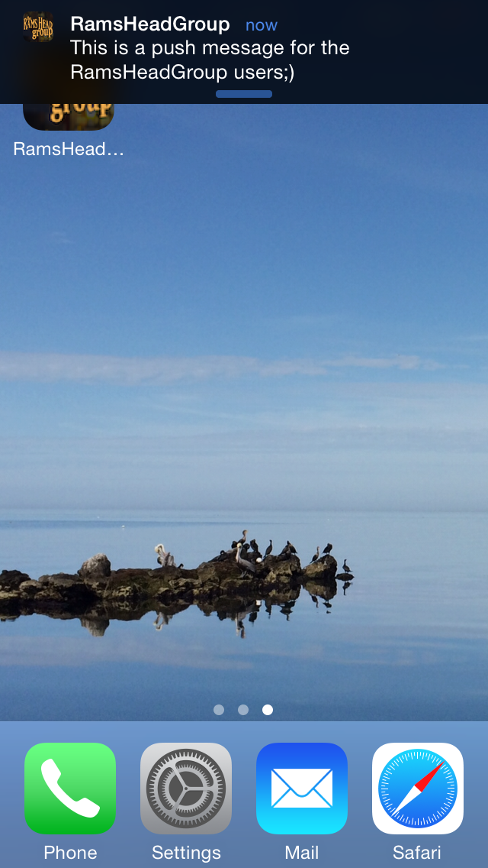

**Login/Register Page Design**

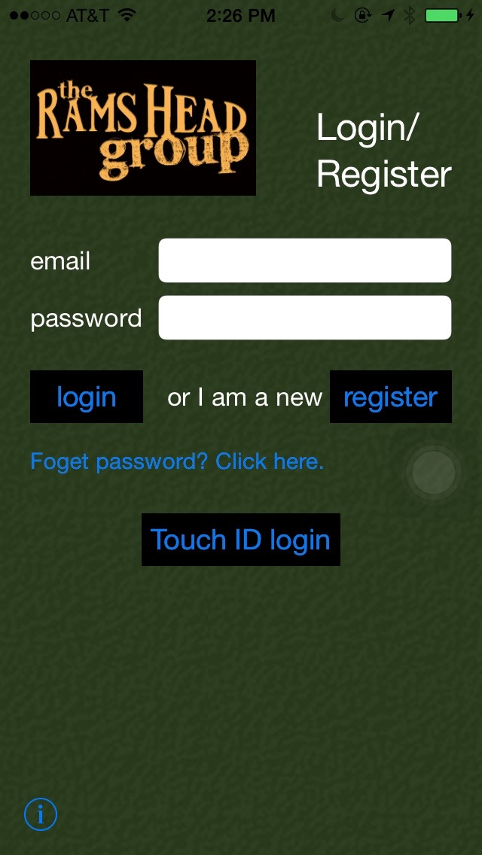**Elements:**

Background: dark green(the same as the website)

Company logo: on the up-left corner, 150x90

Page title: “Login/Register”, white, size 27

“email” label, “password” label, ”or I am a new user,” label: white, size 17

“email” input text field: size 14, email keyboard, Q4

“password” input text field: secure text entry

“login” button:

black background, blue font, segue to list page

“register” button:

black background, blue font, send request to register an account and login

“Foget password? Click here.” button:

segue to Reset password page.

“Touch ID login” button:

Use new feature “Touch ID” authorization in iOS8 to login

“i” (info) button: go back and view the introduction.

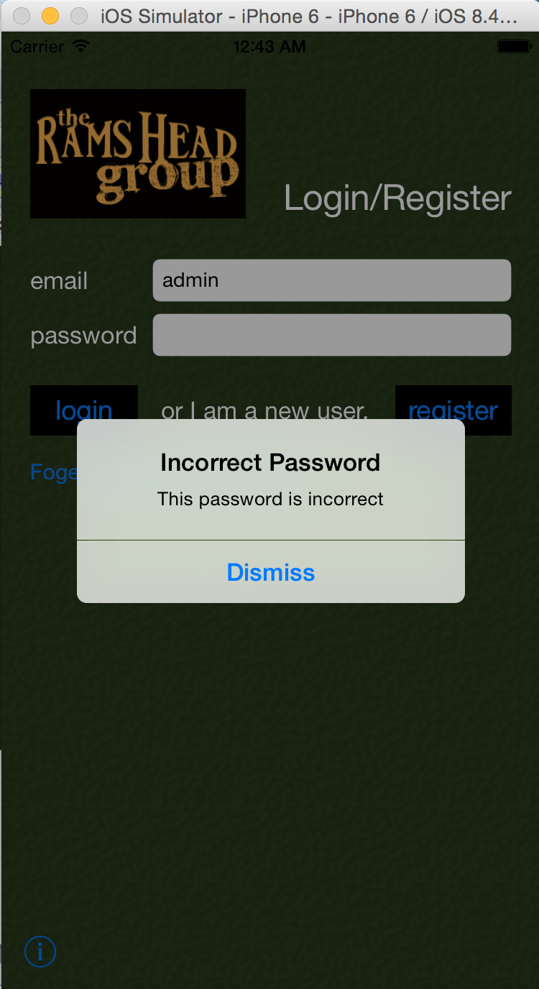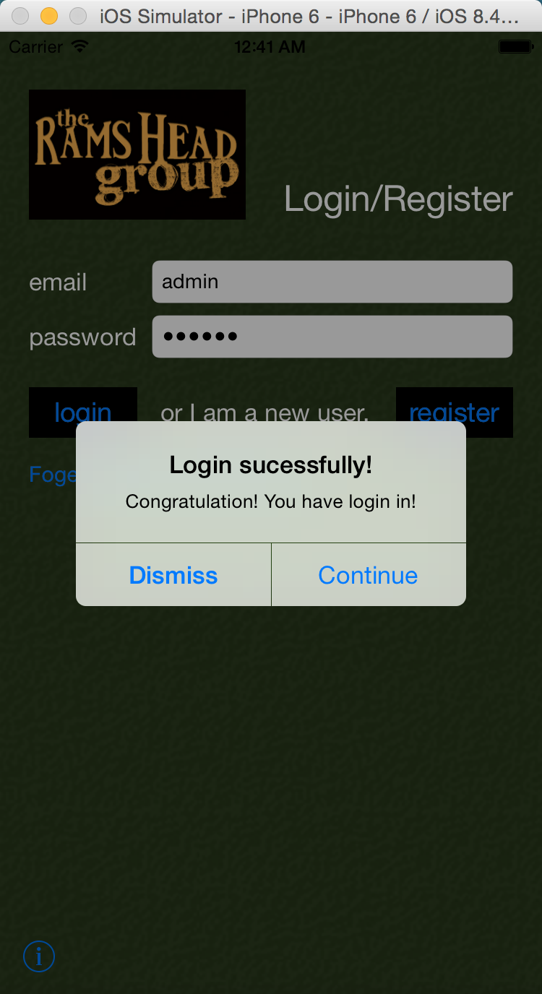

Login with touch ID: (Test in real device)

Fail case:

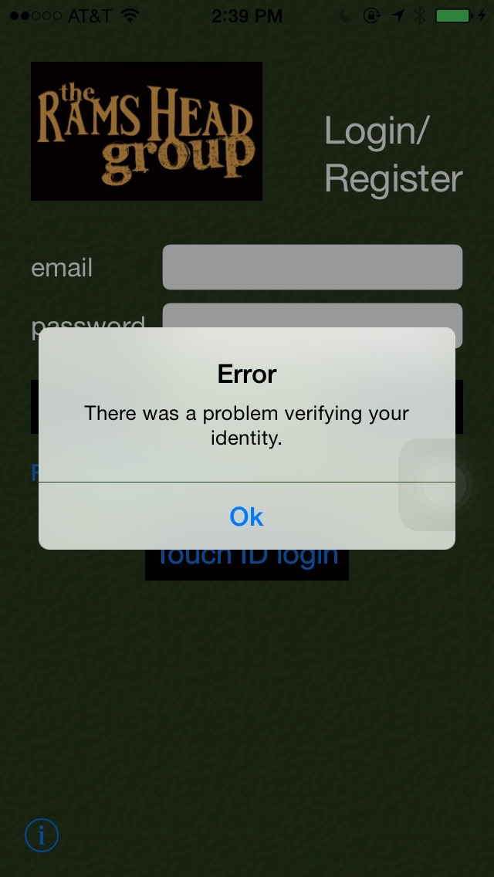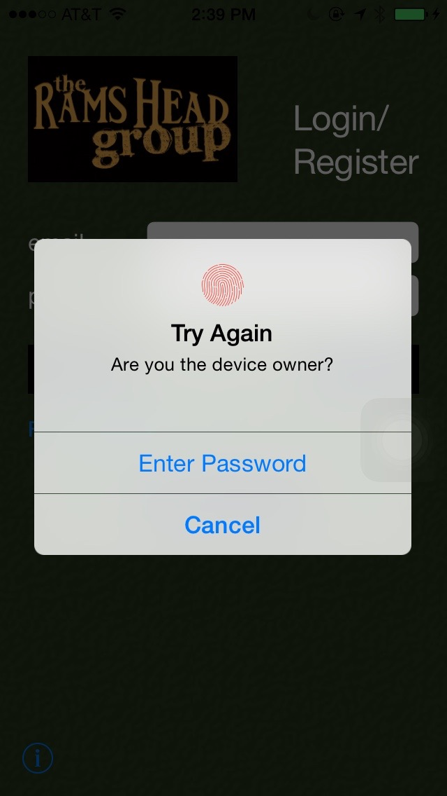

Success case:

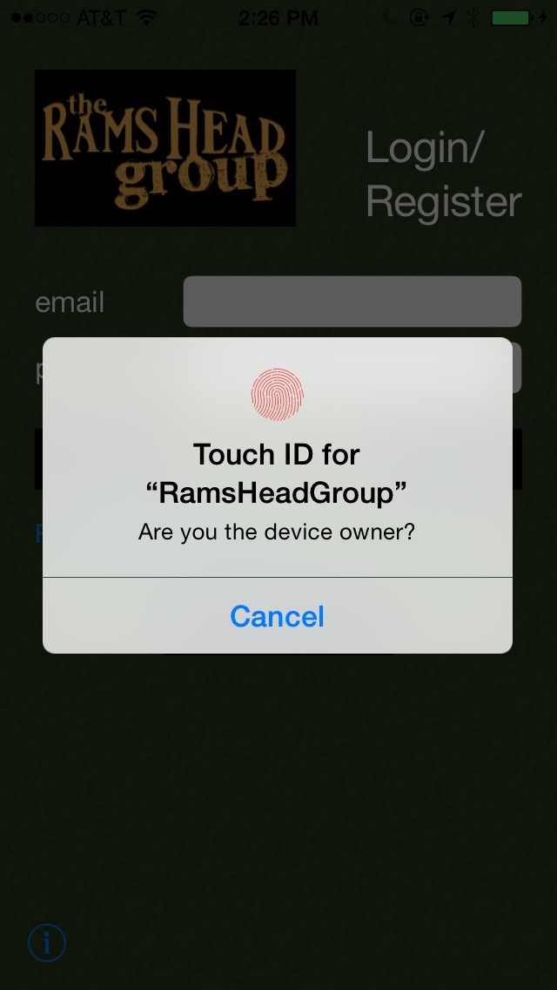

About Page Design

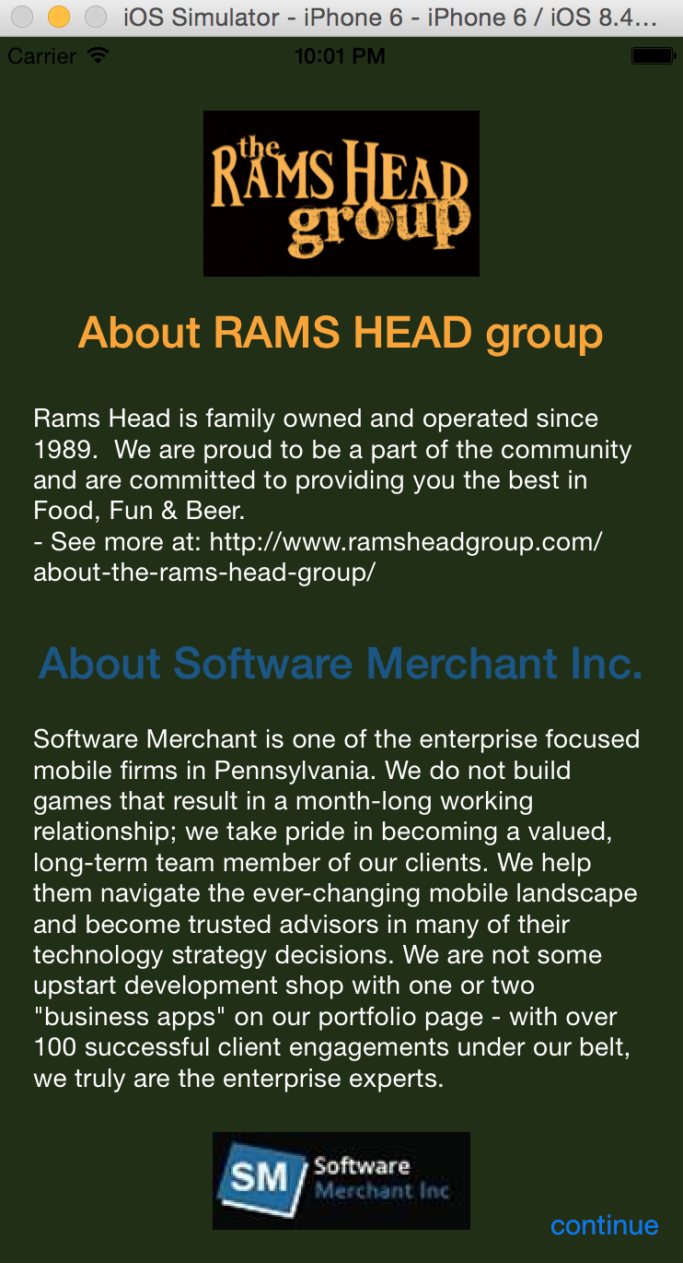

**Elements:**

Status bar: hidden

Background: dark green(according to the website of RAMS HEAD group)

“Rams Head group” logo: cut from the website

About title: 1 for Rams Head group(in orange), 1 for Software Merchant Inc.(in blue)

About content:

font in white, size 14

Part 2. Software Merchant Inc. introduction.

Part 1.

Rams Head group introduction

Software Merchant Logo

“continue” button: segue to the login or register page

**Reset Page Design**

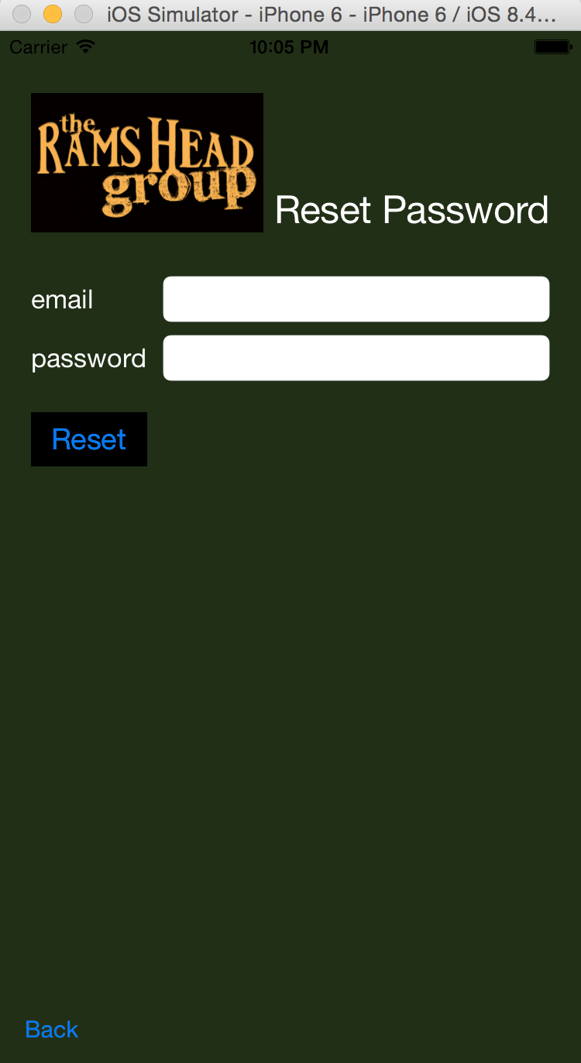**Elements:**

Background: dark green(the same as the website)

Company logo: on the up-left corner, 150x90

Page title: “Login/Register”, white, size 27

“email” label, “password” label: white, size 17

“email” input text field: size 14, email keyboard, Q4

“password” input text field: secure text entry

“reset” button:

black background, blue font, segue to list page

“Back” Button:

segue back to the login/register page.

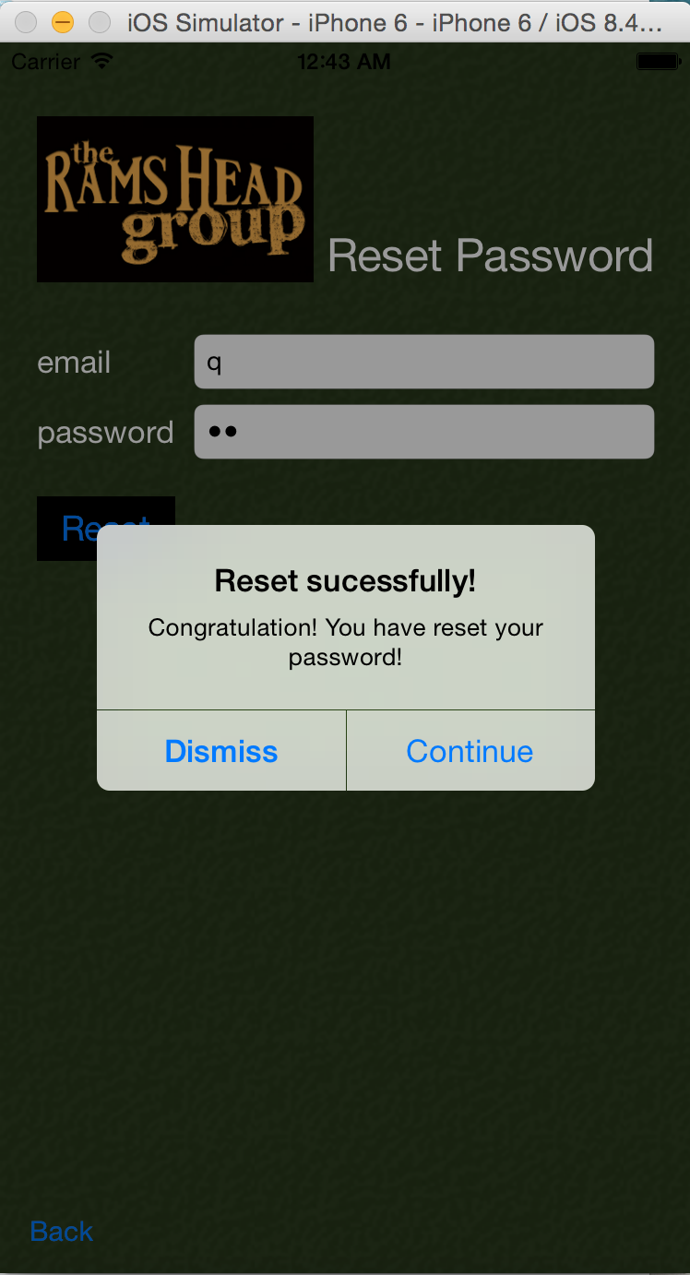

**Menu Page Design**

**Elements:**

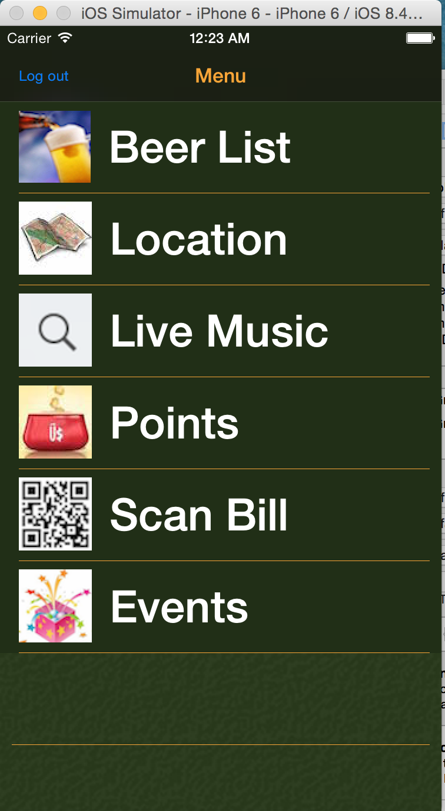

Title: Menu, orange

View Backgroud: black

“Log out” button:

log out account and back to the login page

Cell Background: dark green(the same as the website)

Cell image:

On the left of every cell

Cell content:

White, 50

“Beer List” ,”View On Map”, “Location”, “Live Music”, “Points”, “Scan Bill” and “Events”

Cells Separator: yellow single line

**BeerList & Beer Page Design**

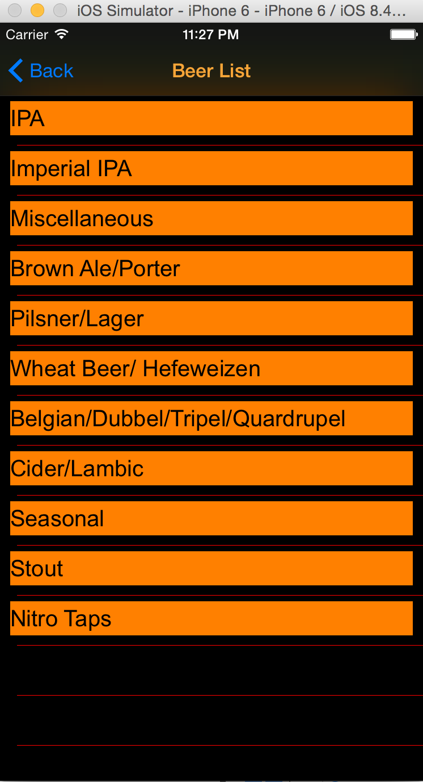

**Elements:**

Title: Beer List, orange

Navigation Buttom: “Back”, blue; back to last page(menu)

View Backgroud: black

Cell Background: black

Cell content:

Label, orange background, black text

Cells Separator: red single line

**Elements:**

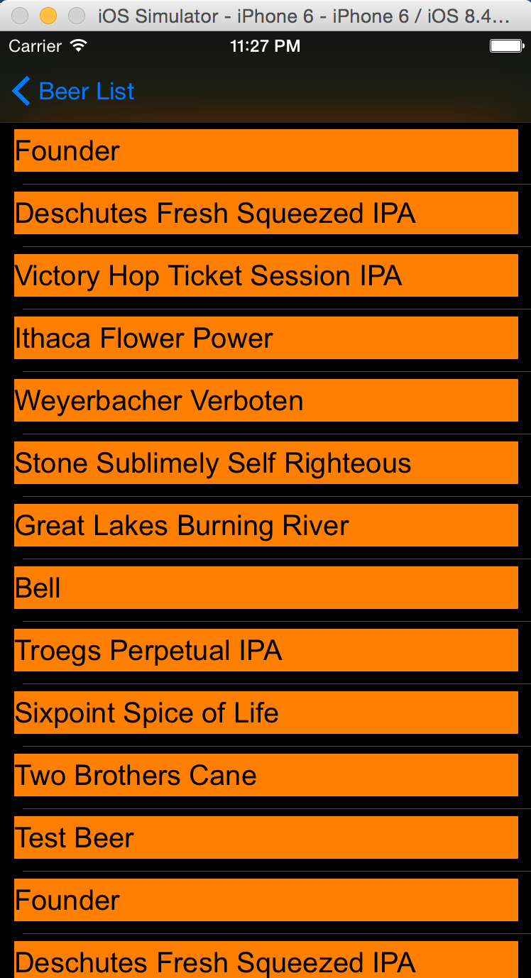

“Back” Buttom: “Beer List”, blue; back to Beer Type List table

View Backgroud: black

Cell Background: black

Cell content:

Label, orange background, black text

Cells Separator: red single line

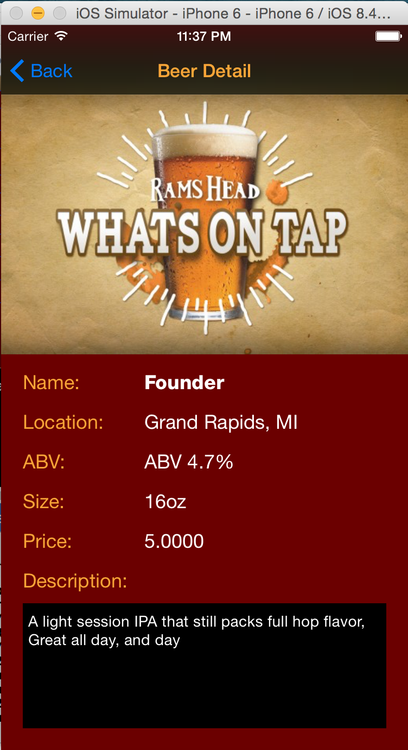**Beer Detail Page Design**

**Elements:**

Title: Beer Detail, orange

Navigation Buttom: “Back”, blue; back to last page(Beer List)

Image: under navigation bar, 300x247

Title labels:

orange, size 18

“Name:”, “Location:”, “ABV”, “Size:”, “Price:”, “Description:”

Beer info labels: white, size 18

“Name” is bold, others are regular

“Description” TextView:

black background, white text, font 17 regular

**LocationList Page Design**

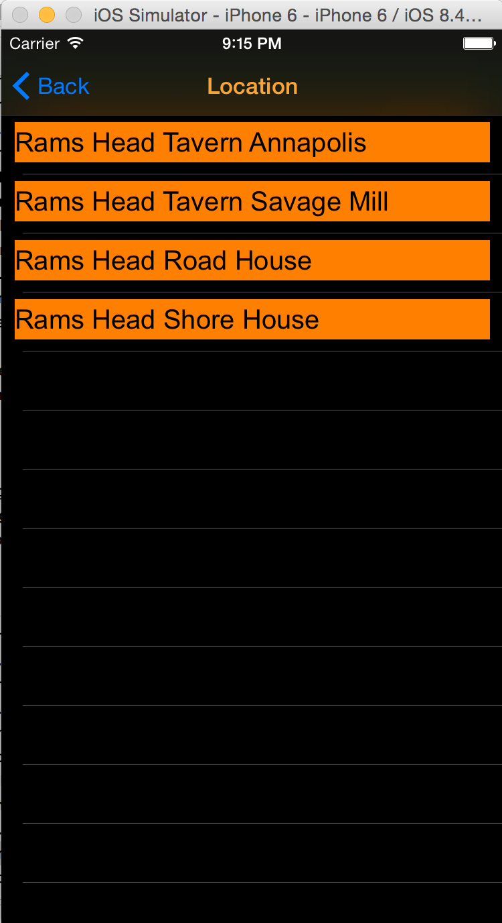**Elements:**

Title: Location, orange

Navigation Buttom: “Back”, blue; back to last page(menu)

View Backgroud: black

Cell Background: black

Cell content:

Label, orange background, black text

List all restaurant names

Cells Separator: red single line

**LocationMap Page Design**

**Elements:**

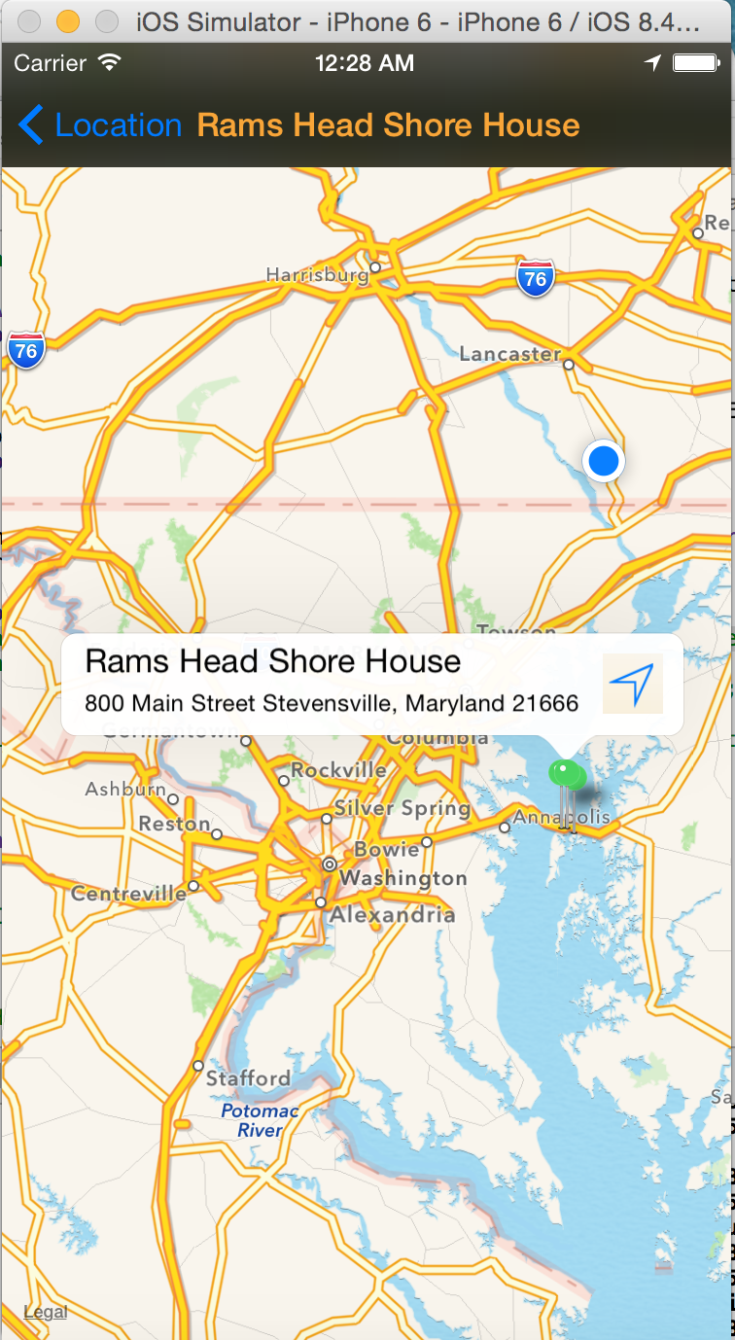Title: Restaurant name, orange

Navigation Button: “Location”, blue; back to last page(Location List)

MapView:

1. showing the name and location of the restaurant(center as the selected restaurant) with pins

2. showing current location with blue point

Green pin:

1. showing the name and detail address of the pin

2. click the right button on the pin view could open a navigation app(from current location to selected pin)—see image of next page

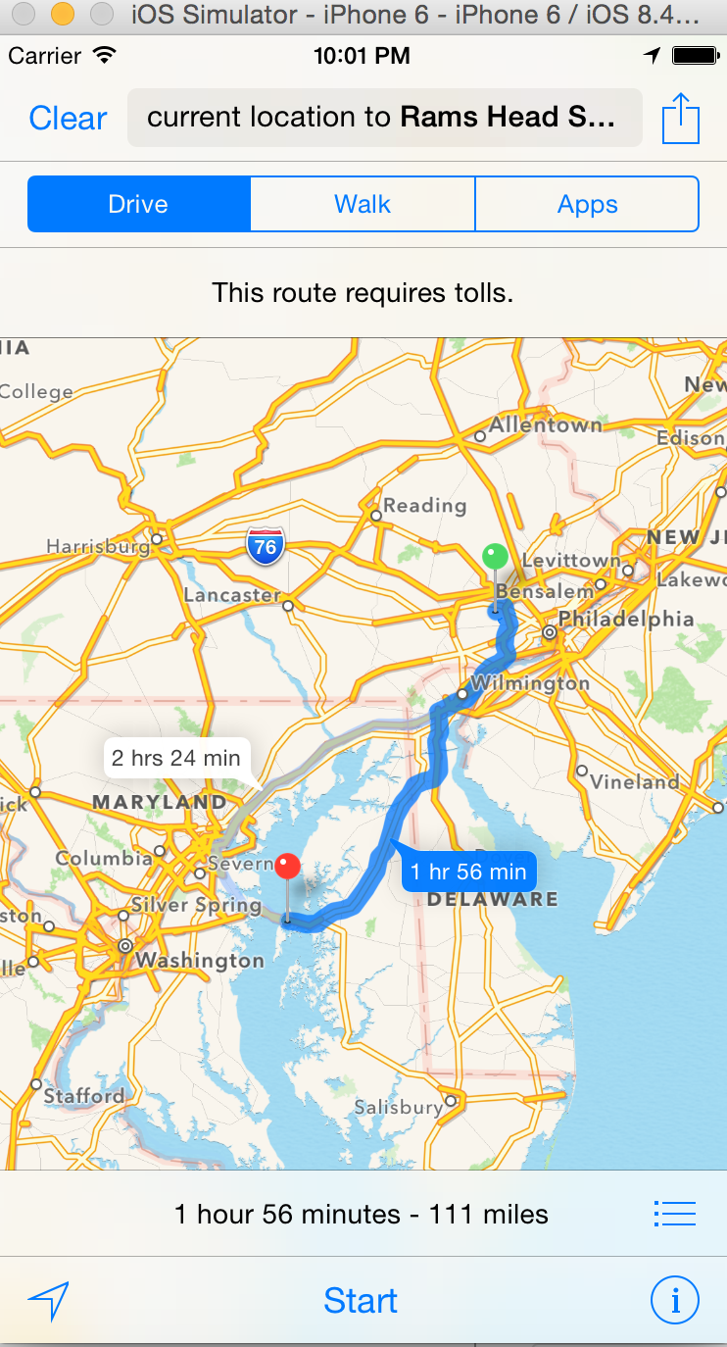

**LiveMusicSearch Page Design**

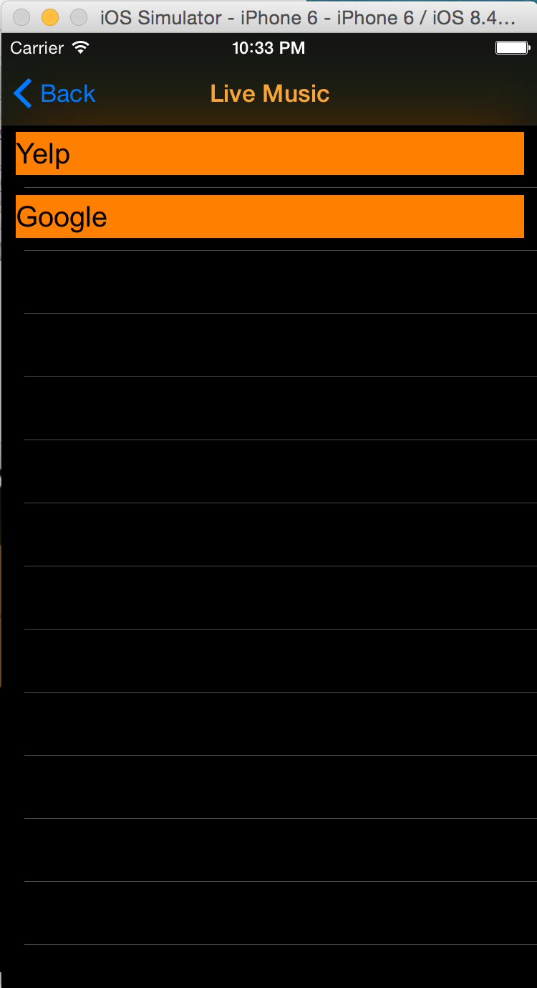**Elements:**

Title: “Live Music”, orange

Navigation Buttom: “Back”, blue; back to last page(menu)

View Backgroud: black

Cell Background: orange

Cell content:

black text

search engine name(“Yelp”, “Google”)

**LiveMusic Page Design**

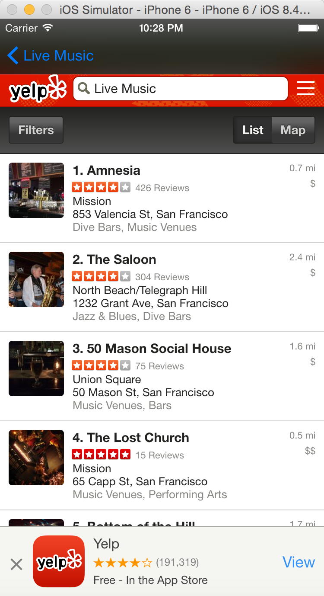**Elements:**

Navigation Buttom: “Live Music”, blue; back to last page(Live Music search list)

View Backgroud: black

Webview:

With filter “Live Music”

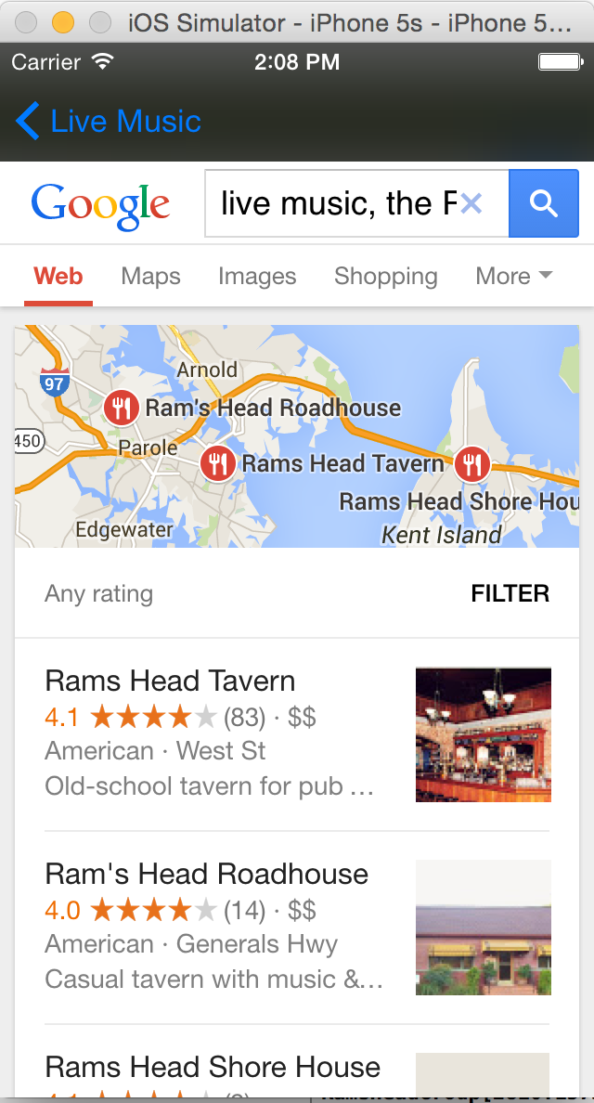

**ViewPoint Page Design**

**Elements:**

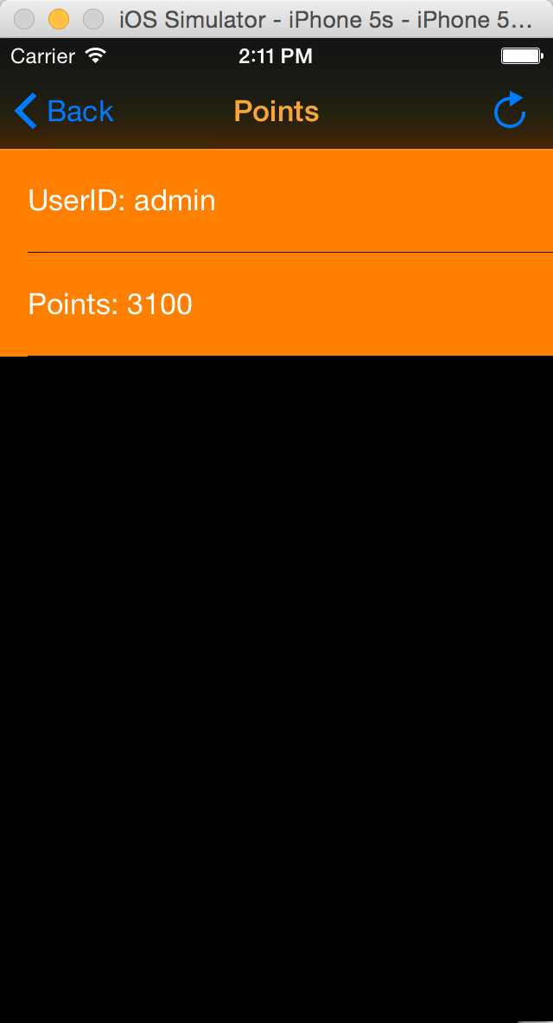

Title: “Points”, orange

Navigation left button: “Back”, blue; back to last page(menu)

Right bar button:

Update the users’ point

View Backgroud: black

Cell Background: brown

Cell content:

white text

“UserID:…” and “Points:…”

**ScanBill Page Design**

(real time scan cannot be tested on simulator)

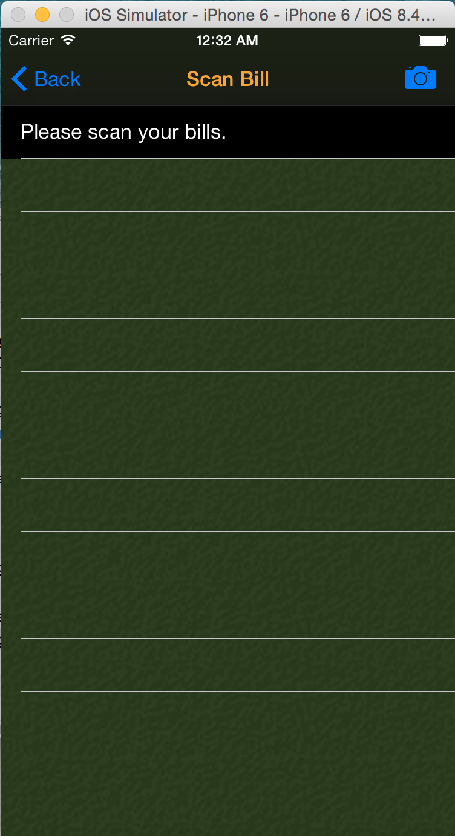**Elements:**

Title: “Scan Bill”, orange

Navigation left button: “Back”, blue; back to last page(menu)

Right bar button:

Camera style, click to scan codes

View Backgroud: image(dark green thyme)

Cells:

Orange background

ROW1:

Show Tips. Black background, white text

Other ROW:

Show “scan result”. Black text

before redeem, gray text after redeem

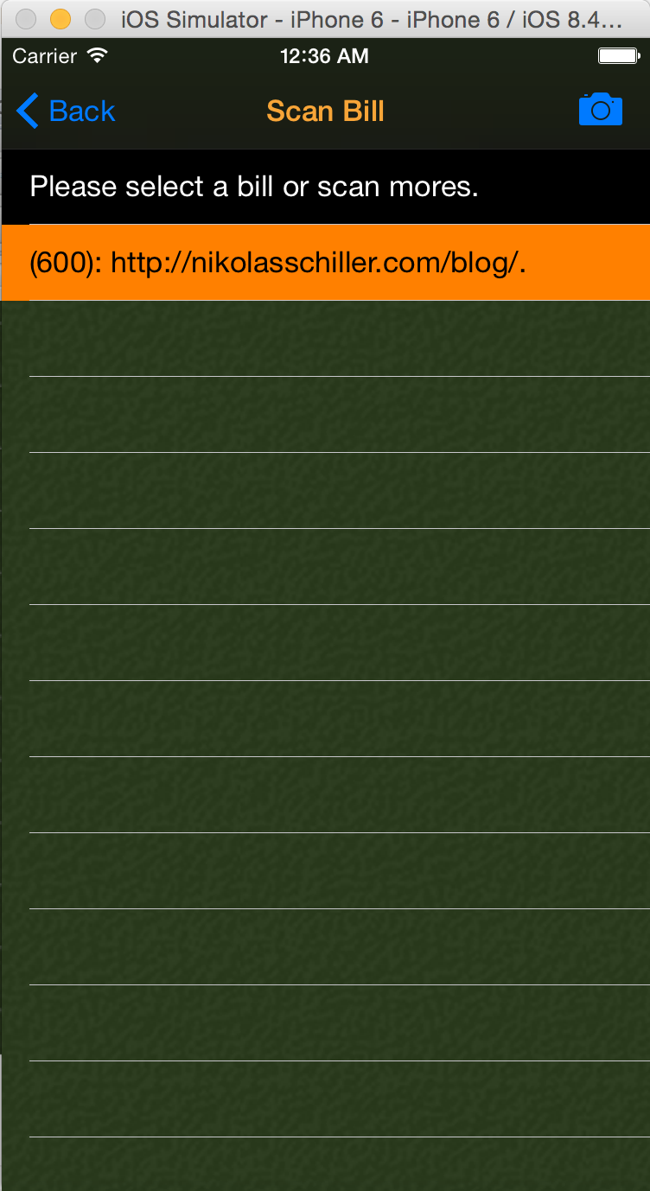

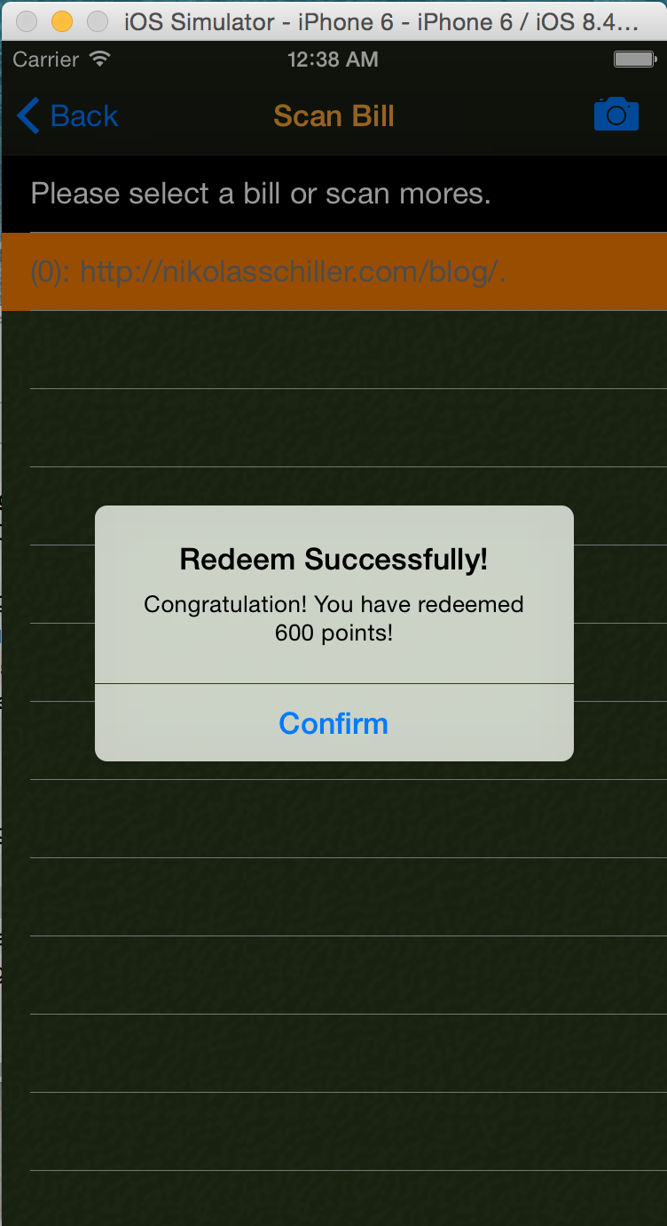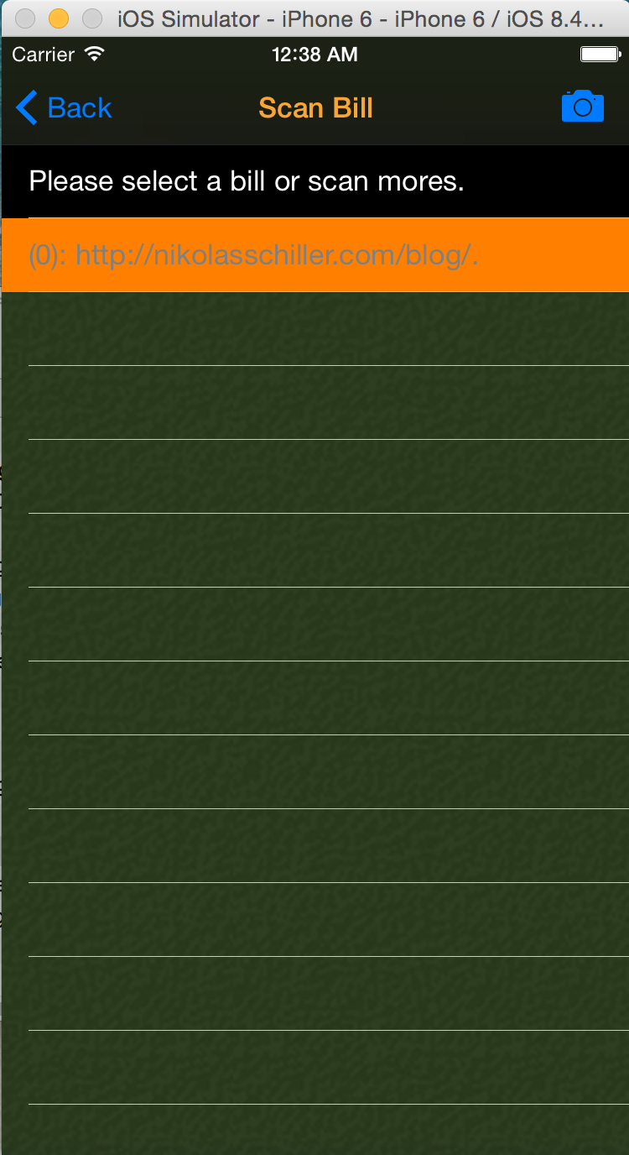

**Events Page Design**

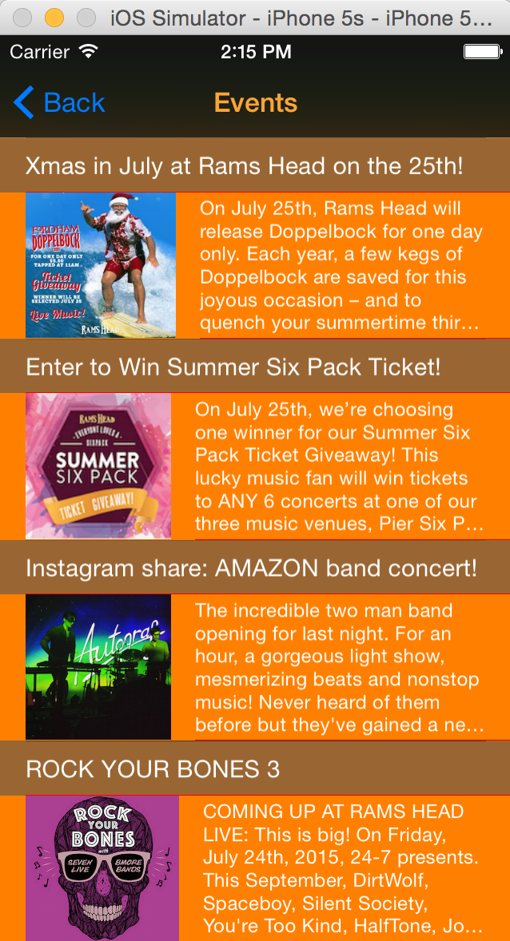**Elements:**

Title: Events, orange

Navigation Buttom: “Back”, blue; back to last page(Menu)

Title Row(even):

White text, event name, font15

Content Row(odd):

Image: left

Content: white text, font 12

Table:

Black background, red separator